**CIRCLES OF SUPPORT**

**INNER CIRCLE:**

**Core**

People you trust and depend on the most.

**Examples:**

* Yourself
* Close Family Members
* Siblings
* Close Friends
* Significant Other

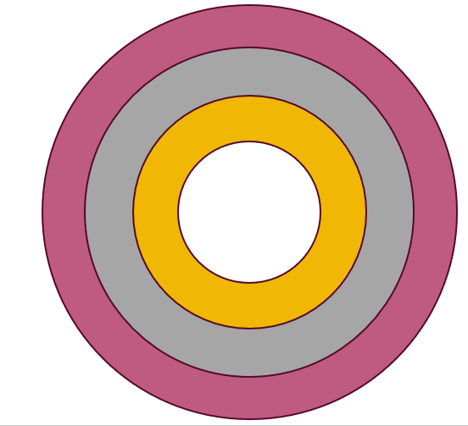

**CIRCLE 2:**

**Relationships**

Close friends/family you would want at a meeting to support you.

**Examples:**

* Friends
* Neighbors
* Cousins, Uncles or Aunts
* Grandparents

**CIRCLE 3:**

**Community**

Groups you belong to and places you like to go.

**Examples:**

* Community Activities
* Church
* YMCA, Boys/Girls Club
* Sports
* Clubs



**OUTER CIRCLE:**

**Exchange**

The people you interact with regularly for services or support.

**Examples:**

* Teacher/School Staff
* Therapist or Doctor
* Mentors or Volunteers
* Co-Workers